SIKSHA 'O' ANUSANDHAN

## (DEEMED TO BE UNIVERSITY)



**Department of Electronics & Communication Engineering, Institute of Technical Education and Research**



**CIRCUIT THEORY**



**(EET2111)**



**DESIGN PROJECT**

|  |  |
| --- | --- |
| **SUBMITTED BY** | |
| NAME: | **Anirban Chatterjee** |
| REGISTRATION NO.: | **2241003014** |
| BRANCH – SECTION: | **ECE-35** |
| SEMESTER: | **4th Semester** |

## DECLARATION

I certify that

1. The work contained in this report is original and has been done by me.
2. I have followed the guidelines provided by the Institute in preparing the report.
3. I have conformed to the norms and guidelines given in the Ethical Code of Conduct of the Institute.
4. I have tried to complete the work with minimum possible cost.
5. Whenever I have used materials (data, theoretical analysis, figures, and text) from other sources, I have given due credit to them by citing them in the text of the report and giving their details in the references.

**Submitted By:**

**Name:**

Anirban Chatterjee

**Regd No:**

2241003014

**Branch:**

ECE

**Section:**

2241035

**Signature**

# PROBLEM STATEMENT

Design an analog computer circuit to solve the differential equation with all

initial conditions are zero.

(d^2V/dt^2)+3(dV/dt)+2V = 10sin(314t)

# CIRCUIT OPERATING CONSTRAINTS

The design of an analog computer circuit to solve the differential equation with

all initial conditions are zero.

(d^2V/dt^2)+3(dV/dt)+2V = 10sin(314t) involve several circuit operating

constraints.

The analog components such as operational amplifiers, resistors, and capacitors must operate in their linear range to maintain accuracy.

The power supply voltages for operational amplifiers should be adequate to prevent saturation. Typically, this involves ensuring the input and output voltages remain within a specific range relative to the supply voltages.

The circuit must be designed to avoid instability and minimize noise, which can distort the solution. This involves proper grounding, shielding, and layout considerations.

Resistor and capacitor values should be chosen with tight tolerances to minimize errors. Variations in component values can lead to inaccuracies in the solution.

The variables in the differential equation should be appropriately scaled to match the voltage and current levels that the analog computer components can handle. This often requires adjusting the amplitude of the signals to fit within the operational range of the circuit elements.

Proper feedback loops must be established to implement the differential equation correctly. This includes ensuring the feedback paths are stable and do not introduce unwanted oscillations.

By adhering to these constraints, an analog computer can effectively solve a second-order differential equation with all initial conditions set to zero. Proper attention to component linearity, power supply range, frequency response, and initial condition setup is crucial for accurate operation.

# THEORETICAL BACKGROUND

## INTRODUCTION

In the realm of computational techniques, analog computers hold a unique position due to their ability to solve differential equations in real-time using continuous physical phenomena. Unlike digital computers, which process information in discrete steps, analog computers leverage the continuous nature of electrical quantities to model and solve complex mathematical problems. This project explores the theoretical underpinnings and practical implementation of an analog computer circuit designed to solve second-order differential equations with zero initial conditions.

Second-order differential equations are prevalent in various fields of science and engineering, describing systems such as harmonic oscillators, RLC circuits, and mechanical vibrations. The ability to solve these equations is crucial for understanding the dynamic behavior of such systems. An analog computer provides a powerful tool for this purpose, using operational amplifiers, resistors, and capacitors to simulate the mathematical operations involved.

This report delves into the theoretical background necessary for constructing an analog computer circuit tailored to solve a second-order differential equation. It begins by outlining the fundamental principles of analog computation, emphasizing the linearity and continuous nature of the components used. The discussion then transitions to the specific configuration required to model a general second-order differential equation of the form:

1. 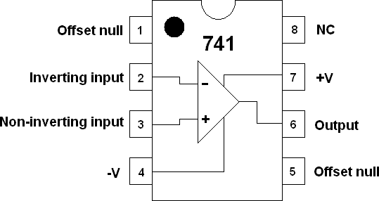**OPAMP**

The 741 OP AMP IC is a monolithic integrated circuit comprising a general-purpose Operational

Amplifier. The number 741 indicates that this operational amplifier has 7 functional pins , 4 pins

capable of taking input and 1 output pin.

The 741 is designed for a wide range of applications, including amplification, filtering, integration,

and analog computation. The 741 can operate with a wide range of supply voltages, typically between ±5V to ±15V.

Its robustness makes it suitable for educational purposes, prototyping, and general-purpose analog design.

The 741 op-amp's simplicity and reliability have made it a staple in analog circuit design, providing a foundational building block for a wide array of electronic applications.

1. **RESISTOR**



Resistors are fundamental components in electrical and electronic circuits, used to control the

flow of electric current and manage voltage levels. They are passive two-terminal devices that provide a specific resistance to the flow of electric current, measured in ohms (Ω). Here are

some key points about resistors:

Function:

Current Limiting: Resistors restrict the amount of current that can flow through a circuit,

protecting sensitive components.

Voltage Division: In voltage divider circuits, resistors create specific voltage drops, enabling

the control of voltage levels within a circuit.

Signal Conditioning: They are used in filtering applications to shape signal characteristics by working with capacitors and inductors.

1. **CAPACITORS**

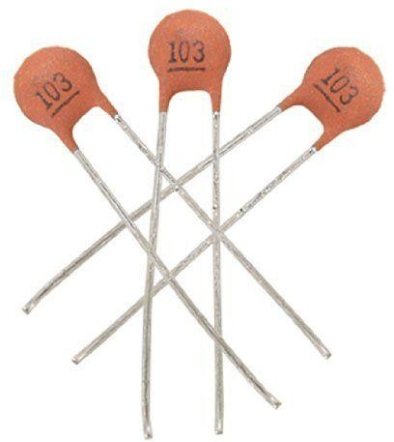

Capacitors are essential passive components in electrical and electronic circuits, used primarily

for storing and releasing electrical energy. They consist of two conductive plates separated by

an insulating material called a dielectric. Here are some key points about capacitors:

Function:

Energy Storage: Capacitors store electrical energy in an electric field created between the plates.

Filtering: They smooth out fluctuations in voltage in power supply circuits and are used in filters

Specifications:

Capacitance: The ability to store charge, measured in farads (F), with common values in microfarads (µF), nanofarads (nF), and picofarads (pF).

Voltage Rating: The maximum voltage a capacitor can handle before it risks breaking down or failing.

Tolerance: Indicates how close the actual capacitance is to the nominal value, expressed as a percentage.

**BLOCK DIAGRAM**

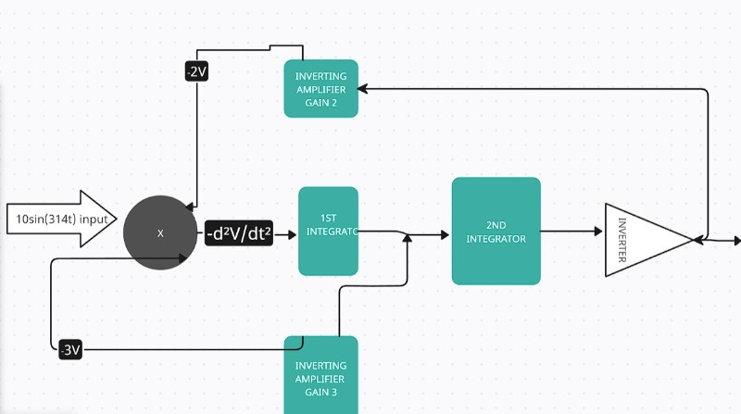

**MATHEMATICAL MODELLING / ANALYSIS**

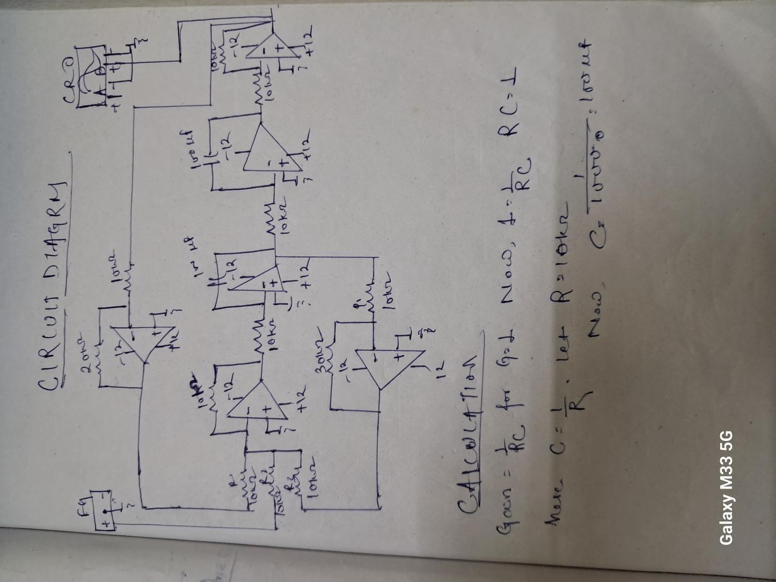

**WORKING**

When the input signal is put into the summing amplifier by using the function generator , it is worked upon by summing , integrator , and inverting amplifier .

The output of the summing amplifier is fed into the first integrator i.e. -d^2V/dt^2 is fed into the

first integrator amplifier .

The output of the first integrator amplifier is +dv/dt . We will notice the change in sign since this

is an integrator amplifier and pin 2 is used for input .

Moreover when the output of first integrator is fed into the second integrator we will receive an inverted result i.e -V

Furthermore this -V is fed into the inverting amplifier as it is understood that we have to invert

the sign so as to obtain the desirable " V".

Last but not the least dV/dt and and -V are fed into the inverting amplifiers having gain 3 and 2 respectively in order to redirect the output to summing amplifier which will lead to the summing

of 10sin(314t) -2V-3(dV/dt) i.e. equal to (d^2V/dt^2)

**CHARACTERISTICS OF THE ANALOG COMPUTER CIRCUIT TO SOLVE THE SECOND**

**ORDER DIFFERENTIAL EQUATION**

The circuit is designed to start from a state where all initial conditions are zero. This is

achieved by ensuring all capacitors in the integrator circuits are initially discharged.

Proper initialization of the circuit prevents erroneous transient behavior at the start.

The use of op-amps with high input impedance ensures minimal loading on the preceding

stages of the circuit, preserving the integrity of the signals.

The circuit, particularly the output stages, has low output impedance, allowing it to drive

various loads without significant signal degradation.

Resistors and capacitors with tight tolerance values are used to minimize deviations from

the desired behavior, ensuring accurate representation of the differential equation.

Typically, a dual power supply (e.g., ±15V) is used to accommodate the bipolar signals and

ensure the proper operation of the operational amplifiers.

The analog computer processes signals in real-time, providing immediate solutions to the differential equation without the delays associated with digital computation.

## CIRCUIT DESIGN

The circuit comprises 6 OP AMPS, 10k Ohm resistors (15 units), 2 capacitors,

Function Generator, CRO and 12V power supply.

The input is fed into the summing amplifier (1st amplifier) and the output of OP

AMP 1 is fed into the second amplifier i.e. the first integrator amplifier.

The output of first integrator amplifier is fed into the second integrator amplifier.

The output of the second integrator amplifier is fed into the inverter amplifier.

Lastly the output from first and second integrator amplifier is fed into the inverting

amplifier with gain 3 and 2 respectively which are then summed along with the

input at the summing point initially to obtain the required output.

# CIRCUIT DIAGRAM

# CT PROJECT CIRCUIT

**DESIGN SPECIFICATION**

|  |  |  |  |  |
| --- | --- | --- | --- | --- |
| **Serial Number** | **Component**  **Name** | **Specification** | **No. of**  **units** | **Price**  **Per**  **Unit** |
| 1. | OPAMP | µA741 | 06 | ₹ 20 |
| 5. | Resistor | 10K, 1K | 15 | ₹ 2 |
| 6. | Capacitor | 0.01uF/ 10nF | 02 | ₹ 5 |
| 7. | Connecting Wires | 23SWG | As per  requirement | ₹40 |
| 8. | TOTAL |  |  | ₹200 |

# HARDWARE SETUP

**Breadboard Implementation**

**Complete Setup**

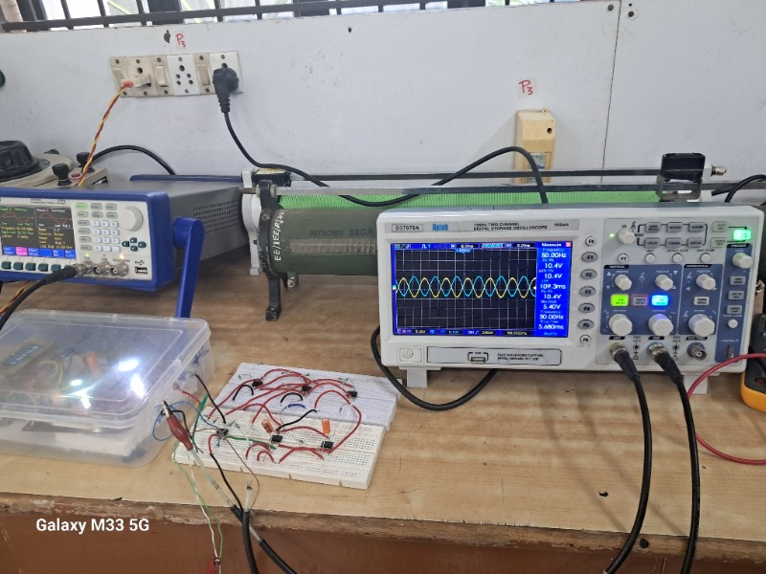

# RESULT

**SIMULATION RESULT**

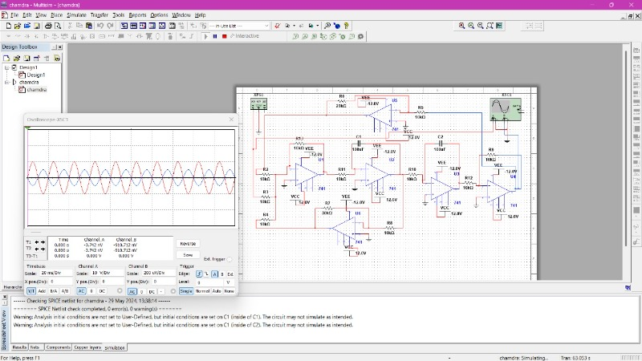

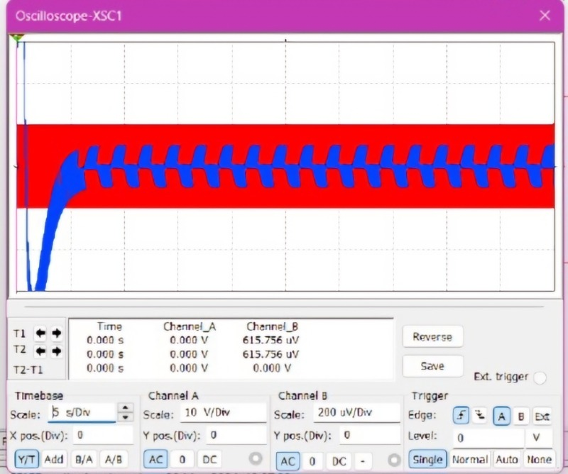

# HARDWARE RESULT

# 

# 

# COMMENTS

The project successfully demonstrated the design and implementation of an analog computer

circuit to solve a second-order differential equation with zero initial conditions. Utilizing operational amplifiers, resistors, and capacitors, the circuit effectively modeled the mathematical operations required to integrate and sum the components of the differential equation. The analog approach provided a real-time solution to the differential equation, showcasing the potential of analog

computing in applications requiring immediate response and continuous processing.

The analog computer provided instantaneous solutions, demonstrating the advantages of analog computation over digital methods in specific scenarios.

Proper initialization ensured that all initial conditions were set to zero, which is crucial for the

accuracy of the solution.

This project underscores the relevance of analog computers in fields such as control systems,

signal processing, and other applications where differential equations play a critical role. The

ability to solve these equations in real-time makes analog computers invaluable in dynamic and

time-sensitive environments.

The accuracy of the solution is highly dependent on the precision of the components used. High-precision resistors and capacitors are essential to minimize errors in the computed solution.

Future projects could explore the impact of component tolerances on the accuracy and stability

of the solution.

This project serves as an excellent educational tool for understanding the principles of differential equations, analog computing, and the practical application of operational amplifiers in complex

circuit design. It bridges theoretical knowledge with practical implementation, providing a comprehensive learning experience.

In conclusion, this project not only demonstrates the feasibility and effectiveness of using an

analog computer to solve a second-order differential equation but also opens up avenues for

further exploration and application in various scientific and engineering domains. The principles learned here are foundational and can be built upon for more complex and diverse computational challenges.

# REFERENCE

* Fundamentals of Electric Circuits 5th Edition by Charles K. Alexander and Matthew N. O. Sadiku
* NESO ACADEMY - https://www.youtube.com/@nesoacademy
* ALL ABOUT ELECTRONICS - https://www.youtube.com/@ALLABOUTELECTRONICS

# DATA SHEET

